Lab 24 task 1: Create a Virtual Machine Alarm to Monitor a Condition
You create an alarm to monitor a condition that occurs on a virtual machine.
1. Using the vSphere Client, log in to sa-vcsa-01.vclass.local by entering administrator@vsphere.local for the user name and VMware1! for the password.
2. From the Menu drop-down menu, select VMs and Templates.
3. Power on the Win10-02 virtual machine.
a. In the navigation pane, right-click Win10-02 and select Power > Power On.
4. Right-click Win10-02 and select Alarms > New Alarm Definition.
The New Alarm Definition wizard opens.
Because you are creating an alarm for the Win10-02 virtual machine object, this alarm monitors only that object. If you set the alarm on an object higher in the vCenter Server inventory, the alarm applies to the parent object and al relevant child objects in the hierarchy.
5. On the Name and Targets page, enter Win10-02 CPU Usage in the Alarm Name text box.
The target type is Virtual Machine and the target object is Win10-02.
6. Click NEXT.
7. On the Alarm Rule 1 page, define the trigger condition.
If VM CPU Usage is above 50% for 30 seconds, then trigger the alarm and show the alarm as Warning.
a. From the first drop-down menu, select VM CPU Usage.
b. From the select an operator drop-down menu, select is above.
c. In the % text box, enter 50.
d. From the last drop-down menu, select 30 sec.
e. From the select severity drop-down menu, select Show as Warning.
The alarm rule should look like this:
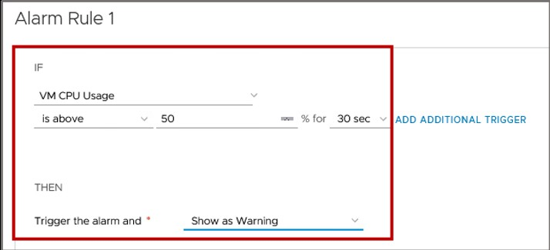
f. Click NEXT.
8. On the Reset Rule 1 page, read the rule and do not change anything.
The reset rule is to reset the alarm to Normal if the warning condition is no longer met.
9. Click NEXT.
10. On the Review page, review the alarm information.
The alarm is enabled by default.
11. Click CREATE.
12. Verify that the alarm definition is created.
a. In the navigation pane, select Win10-02 and click the Configure tab.
b. In the right pane, select Alarm Definitions.
c. Verify that the Win10-02 CPU Usage alarm appears in the alarm list.
d. If you cannot easily find the alarm, use the filter in the Alarm Name column and search for some or all of the alarm name.

